Versions:

Date | Version | Author | Commments
28.10.2025 | 0.2 | Oros Raul-Andrei

Analisys&Design for <Emergency Alert System>

Content:
- General Presentation

- Theoretical Fundamentals

- IT Technology (which will be implemented)

- Functionalities

- Actors and related access rights

- Use Case Diagrams

- System Architecture

- Design (UML Diagrams)

- Operation Mode (Operation Guide, including screen-shots)

- Portability

- General Presentation
The Emergency Alert System (EAS) is a Smart City application designed to enable citizens to quickly report emergencies such as fires, medical incidents, crimes, and infrastructure failures.
The system provides real-time communication between Citizens, Responders (police, firefighters, medical teams), and Administrators (control center staff).
The main objectives are:
    - Reduce emergency response times
    - Provide fast and accurate routing of alerts
    - Improve coordination between emergency agencies
    - Provide real-time status updates to all involved actors

The system is designed as a web and mobile-friendly application, built using a client–server architecture with a Flask backend and a MariaDB relational database.

- Theoretical Fundamentals
The system is based on several theoretical and informational technology concepts:
  - Client-Server Architecture
The application follows a 3-tier model:
        - Presentation layer (web / mobile UI)
        - Application layer (Flask backend)
        - Data layer (MariaDB database)
  - RESTful Web Services
All operations (reporting incidents, updating statuses, assigning responders) are based on REST principles.
  - CRUD operations
The data model supports Create, Read, Update, Delete interactions for objects like Alerts, Users, and Assignments.
  - Authentication & Authorization
Users authenticate using Flask-Login.
Authorization is enforced through role-based access control (RBAC):
      - Citizen
      - Responder
      - Admin

- IT Technology
The system uses the following technologies:
  - Backend
    - Python 3
    - Flask (web framework)
    - Flask-login (session management)
    - Flask-SQLAlchemy (ORM)
    - Werkzeug (password hashing)
  - Database
    - MariaDB (relational database)
    - SQLAlchemy ORM mapping
    - Tables: Users, Alerts, ResponderAssigments, Notifications
  - Frontend
    - HTML, CSS, JavaScript
  - Development Tools
    - Visual Studio Code
    - Virtual environment (venv)
    - Diagrams.net / draw.io (for UML diagrams)
    - Git

- Functionalities
  - Citizen Functionalities
    - Register and log in
    - Report an emergency
    - Attach description, severity
    - View their alert status in real-time
    - Receive notifications when responder is assigned or alert is resolved
  - Admin Functionalities
    - Log in
    - View all active alerts
    - Assign responders to alerts
    - Update alerts status
    - Resolve and archive alerts
  - Responder Functionalities
    - Log in
    - View assigned alerts
    - Mark alert as “On route”
    - Mark alert as “Resolved”
    - Provide intervention information
  - System Functionalities
    - Store alerts and user actions in database
    - Manage roles and permissions
    - Chronological history for each alert
    - Update dashboards dynamically

- Actors and related access rights

Actor | Description | Access Rights
Citizen | Person using the app to report emergencies | Report alert, view own alerts
Administrator | Control center | View all alerts, assign responders, update statuses
Responder | Police, Firefighter, Medical | View assigned alerts, update their status
System | Backend application | Data validation, notifications, scheduling

- Use Case Diagrams
  - Use Case Diagram – Administrator
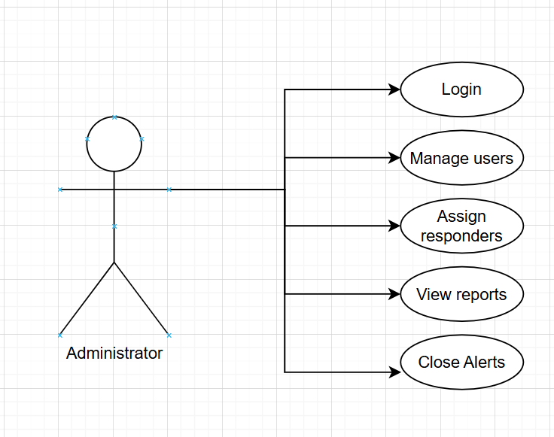
  - Use Case Diagram – Citizen

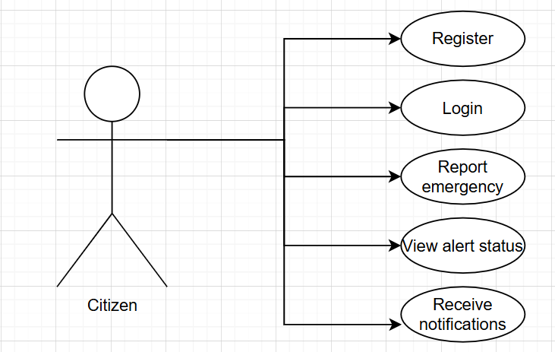

  - Use Case Diagram – Responder

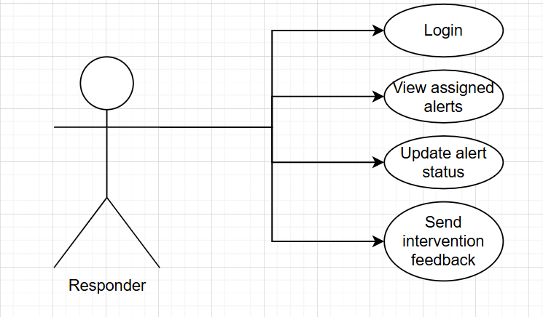

- System Architecture

- Design
  - General architecture diagram

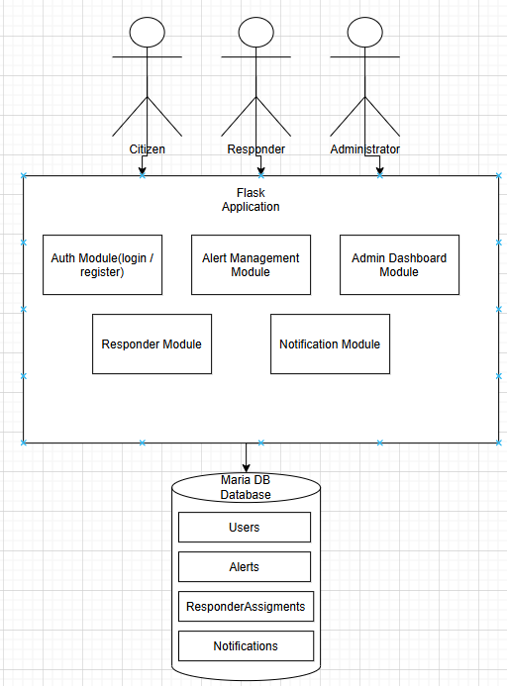

  - Flow charts
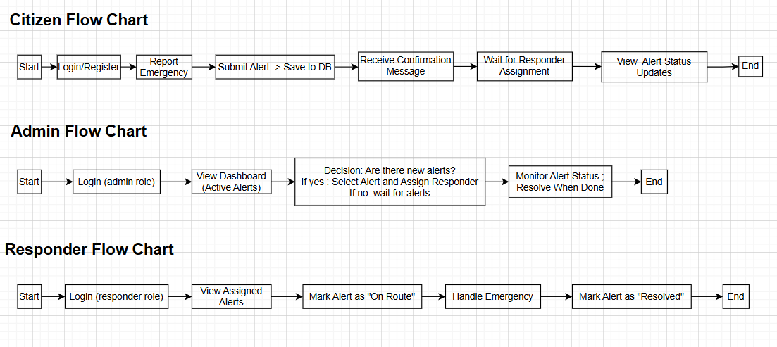

  - Class diagram
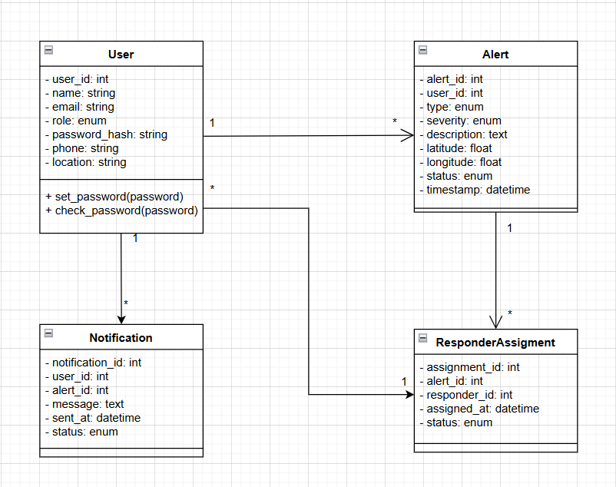
  - Object diagram
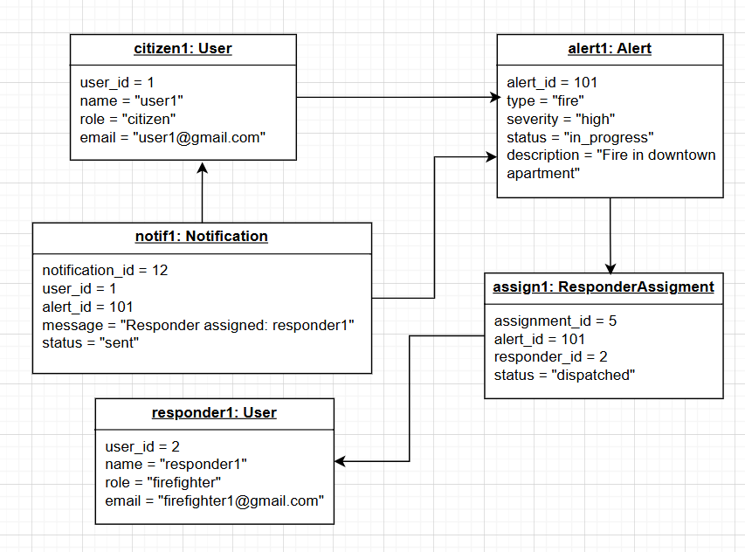

  - Activity diagram
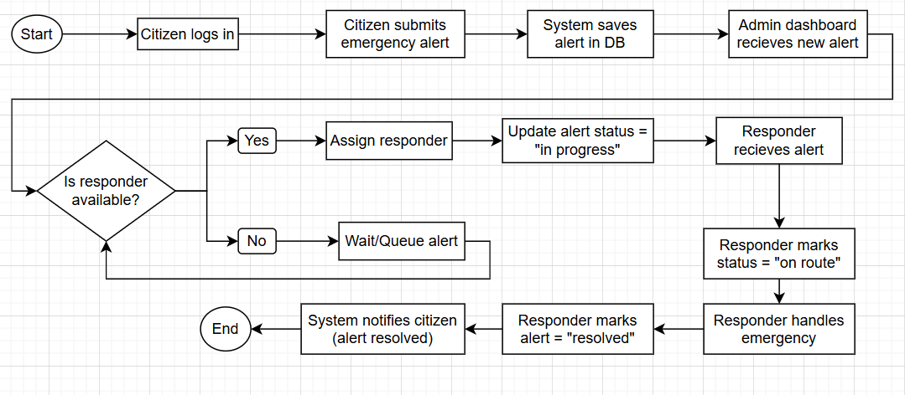

  - State transition diagram
  - Sequence diagram
  - Communication diagram
  - Component diagram
  - Package diagram
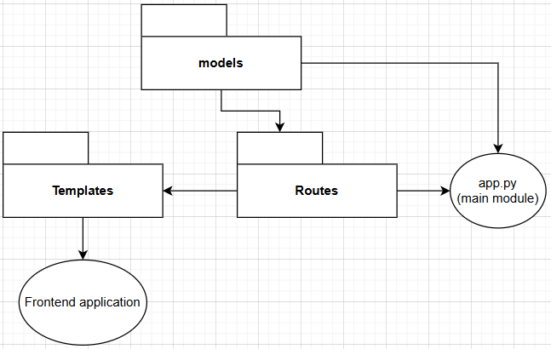
  - Deployment diagram
  - DB diagram

- Operation Mode (Interactivity presentation) + screen shots (UI design)
  - Citizen operation:
    - User logs in
    - Reports incident
    - Views alert status
    - Receives updates
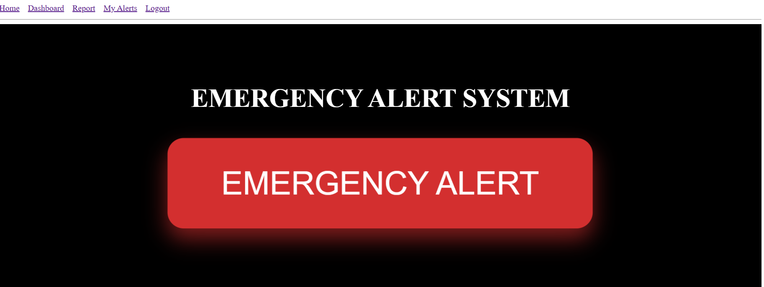

  - Admin operation:
    - Logs in
    - Views dashboard
    - Assigns responders
    - Updates status
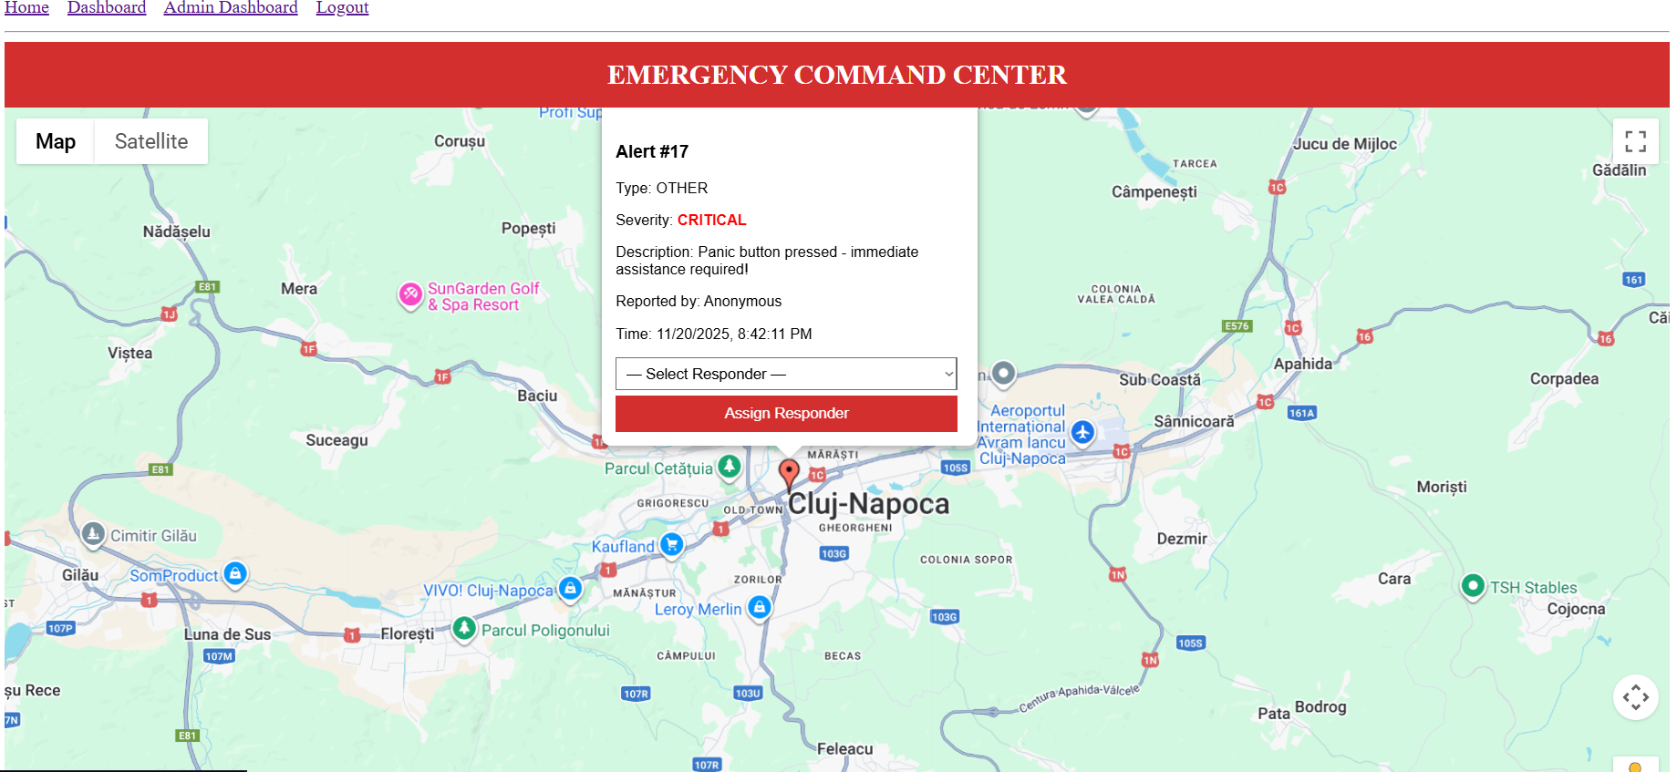

  - Responder Operation:
    - Logs in
    - Views assigned alerts
    - Marks “on route”
    - Marks “resolved”
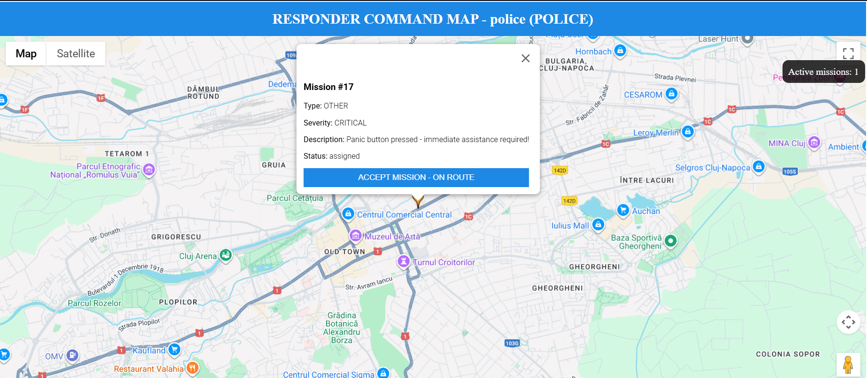

- Portability
  - The system is portable because:
    - It runs on any OS supporting python (Window, MacOS, Linux)
    - The frontend runs on any browser or mobile device
    - MariaDB is cross platform
    - Flask application can be deployed on servers
    - The responsive nature of the UI makes it usable on smartphones

- Competing software

